The Holy Eucharist
Fifth Sunday after Easter
Sunday, May 15, 2022
10:00 AM Rite II

Join us on Facebook as we live stream this Eucharist:
www.facebook.com/cgsreading/live/

Wherever you are on your journey with God or toward God, you are welcome here.
Masks wearing is encouraged but not required.

Liturgy of the Word
Prelude O Perfect Love Hal H. Hopson
Greeting

Gathering Song God is Love Hymnal #379

Opening Acclamation
Presider: Alleluia! Christ is risen!
People: The Lord is risen indeed! Alleluia!

Collect for Purity
Almighty God, to you all hearts are open, all desires known, and from you no secrets are hid: Cleanse the thoughts of our hearts by the inspiration of your Holy Spirit, that we may perfectly love you, and worthily magnify your holy Name; through Christ our Lord. Amen.

Gloria

Collect of the day

Presider: The Lord be with you.
People: And also with you.
Presider: Let us pray:

Almighty God, whom truly to know is everlasting life: Grant us so perfectly to know your Son Jesus Christ to be the way, the truth, and the life, that we may steadfastly follow his steps in the way that leads to eternal life; through Jesus Christ your Son our Lord, who lives and reigns with you, in the unity of the Holy Spirit, one God, for ever and ever. Amen.

First Reading: Acts 11:1-18

A Reading from the Acts of the Apostles.
Now the apostles and the believers who were in Judea heard that the Gentiles had also accepted the word of God. So when Peter went up to Jerusalem, the circumcised believers criticized him, saying, "Why did you go to uncircumcised men and eat with them?" Then Peter began to explain it to them, step by step, saying, "I was in the city of Joppa praying, and in a trance I saw a vision. There was something like a large sheet coming down from heaven, being lowered by its four corners; and it came close to me. As I looked at it closely I saw four-footed animals, beasts of prey, reptiles, and birds of the air. I also heard a voice saying to me, `Get up, Peter; kill and eat.' But I replied, `By no means, Lord; for nothing profane or unclean has ever entered my mouth.' But a second time the voice answered from heaven, `What God has made clean, you must not call profane.' This happened three times; then everything was pulled up again to heaven. At that very moment three men, sent to me from Caesarea, arrived at the house where we were. The Spirit told me to go with them and not to make a distinction between them and us. These six brothers also accompanied me, and we entered the man's house. He told us how he had seen the angel standing in his house and saying, `Send to Joppa and bring Simon, who is called Peter; he will give you a message by which you and your entire household will be saved.' And as I began to speak, the Holy Spirit fell upon them just as it had upon us at the beginning. And I remembered the word of the Lord, how he had said, `John baptized with water, but you will be baptized with the Holy Spirit.' If then God gave them the same gift that he gave us when we believed in the Lord Jesus Christ, who was I that I could hinder God?" When they heard this, they were silenced. And they praised God, saying, "Then God has given even to the Gentiles the repentance that leads to life."

The Word of the Lord
Thanks be to God.

Psalm 148
Hallelujah! Praise the Lord from the heavens; *
praise him in the heights.
Praise him, all you angels of his; *
praise him, all his host.
Praise him, sun and moon; *
praise him, all you shining stars.
Praise him, heaven of heavens, *
and you waters above the heavens.
Let them praise the Name of the Lord; *
for he commanded, and they were created.
He made them stand fast for ever and ever; *
he gave them a law which shall not pass away.
Praise the Lord from the earth, *
you sea-monsters and all deeps;
Fire and hail, snow and fog, *
tempestuous wind, doing his will;
Mountains and all hills, *
fruit trees and all cedars;
Wild beasts and all cattle, *
creeping things and winged birds;
Kings of the earth and all peoples, *
princes and all rulers of the world;
Young men and maidens, *
old and young together.
Let them praise the Name of the Lord, *
for his Name only is exalted, his splendor is over earth and heaven.
He has raised up strength for his people
and praise for all his loyal servants, *
the children of Israel, a people who are near him. Hallelujah!

Second Reading: Revelation 21:1-6

A Reading from the Book of Revelation.
I saw a new heaven and a new earth; for the first heaven and the first earth had passed away, and the sea was no more. And I saw the holy city, the new Jerusalem, coming down out of heaven from God, prepared as a bride adorned for her husband. And I heard a loud voice from the throne saying,
"See, the home of God is among mortals.
He will dwell with them as their God;
they will be his peoples,
and God himself will be with them;
he will wipe every tear from their eyes.
Death will be no more;
mourning and crying and pain will be no more,
for the first things have passed away."
And the one who was seated on the throne said, "See, I am making all things new." Also he said, "Write this, for these words are trustworthy and true." Then he said to me, "It is done! I am the Alpha and the Omega, the beginning and the end. To the thirsty I will give water as a gift from the spring of the water of life."
The Word of the Lord
Thanks be to God.

Gospel Acclamation Celtic Alleluia

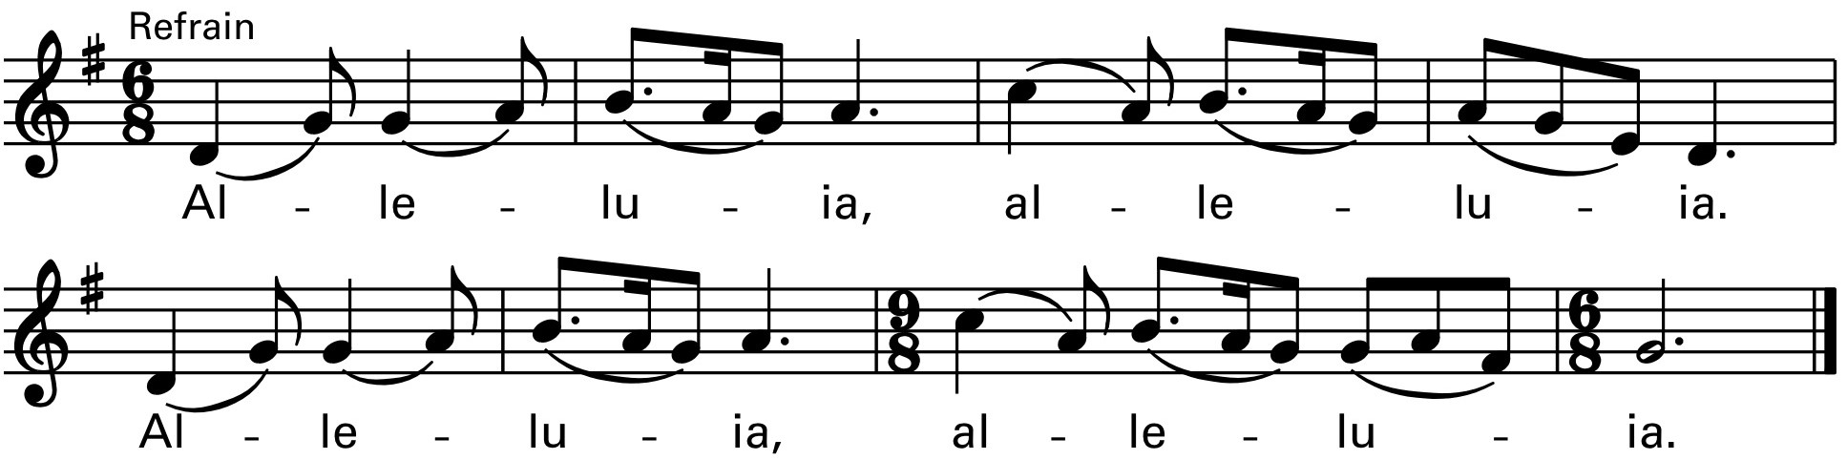

Gospel: John 13:31-35
The Holy Gospel of our Lord Jesus Christ according to John
Glory to you, Lord Christ.

At the last supper, when Judas had gone out, Jesus said, "Now the Son of Man has been glorified, and God has been glorified in him. If God has been glorified in him, God will also glorify him in himself and will glorify him at once. Little children, I am with you only a little longer. You will look for me; and as I said to the Jews so now I say to you, 'Where I am going, you cannot come.' I give you a new commandment, that you love one another. Just as I have loved you, you also should love one another. By this everyone will know that you are my disciples, if you have love for one another."
The Gospel of the Lord.
Praise to you, Lord Christ.

Sermon The Rev. Brian Raiche

The Nicene Creed
We believe in one God,
the Father, the Almighty,
maker of heaven and earth,
of all that is, seen and unseen.
We believe in one Lord, Jesus Christ,
the only Son of God,
eternally begotten of the Father,
God from God, Light from Light,
true God from true God,
begotten, not made,
of one Being with the Father.
Through him all things were made.
For us and for our salvation
he came down from heaven:
by the power of the Holy Spirit
he became incarnate from the Virgin Mary,
and was made man.
For our sake he was crucified under Pontius Pilate;
he suffered death and was buried.
On the third day he rose again
in accordance with the Scriptures;
he ascended into heaven
and is seated at the right hand of the Father.
He will come again in glory to judge the living and the dead,
and his kingdom will have no end.

We believe in the Holy Spirit, the Lord, the giver of life,
who proceeds from the Father and the Son.
With the Father and the Son he is worshiped and glorified.
He has spoken through the Prophets.
We believe in one holy catholic and apostolic Church.
We acknowledge one baptism for the forgiveness of sins.
We look for the resurrection of the dead,
and the life of the world to come. Amen.
Prayers of the People Form III BCP

Deacon: On this Day, let us joyfully offer our prayers to the Lord:

Father, we pray for your holy catholic Church; That we all may be one.

Grant that every member of the Church may truly and humbly serve you;
That your Name may be glorified by all people.

We pray for Michael, our presiding bishop; Alan and Gayle, our bishops; Brian our priest, Pete our deacon, and for all bishops, priests, and deacons;
That they may be faithful ministers of your Word and Sacraments.

We pray for all who govern and hold authority in the nations of the world;
That there may be justice and peace on the earth.

Give us grace to do your will in all that we undertake;
That our works may find favor in your sight.

Have compassion on those who suffer from any grief or trouble;
That they may be delivered from their distress.

Give to the departed eternal rest. We remember especially John Newton who died this week and for Frank and Eleanor Dalrymple, Joseph McDonald, and Philip Royce, in whose name the altar flowers are given. Eternal rest grant unto them, O Lord.
Let light perpetual shine upon them.

We praise you for your saints who have entered into joy;
May we also come to share in your heavenly kingdom.

Give comfort to those who suffer because of violence especially the people of Ukraine. Convert the hearts of those who resort to arms and protect those who work to promote peace. May war be banished from the earth.
Let us pray for our own needs and those of others. We remember especially those on our parish prayer list. We give special thanks for those in our parish family who are celebrating birthdays this week: Connor Edge, Rob Goodwin, Leslie McGovern, Kevin Delano, Katherine Luddy, and Alexander Witham, and those celebrating anniversaries this week: Jack and Karen Marlin, and Rob and Stephanie Klages.

Alleluia! Christ is risen! The Lord is risen indeed! Alleluia!

Presider:
Lord Jesus Christ, you said to your apostles, “Peace I give to you; my own peace I leave with you:” Regard not our sins, but the faith of your people, the Church, and give to us the peace and unity of that heavenly city, where with the Father and the Holy Spirit you live and reign, now and for ever. AMEN.

The Peace
Presider: The peace of the Lord be always with you.
People: And also with you.
Liturgy of the Table
Invitation
Walk in love, as Christ loved us and gave himself for us, an offering and sacrifice to God.

Preparation of the Table Lord, We Sing to You Greg Sheer

Easter Doxology Lasst Uns Erfreuen

Praise God, from whom all blessings flow;
praise God, all creatures here below; Alleluia! Alleluia!
praise God above, ye heavenly host:
praise Father, Son, and Holy Ghost.
Alleluia! Alleluia! Alleluia! Alleluia! Alleluia!

The Great Thanksgiving Eucharistic Prayer A

Presider: The Lord be with you.
People: And also with you.

Presider: Lift up your hearts.
People: We lift them to the Lord.

Presider: Let us give thanks to the Lord our God.
People: It is right to give God thanks and praise.

It is right, and a good and joyful thing, always and ever where to give thanks to you, Father Almighty, Creator of heaven and earth. But chiefly are we bound to praise you for the glorious resurrection of your Son Jesus Christ our Lord; for he is the true Paschal Lamb, who was sacrificed for us, and has taken away the sin of the world. By his death he has destroyed death, and by his rising to life again he has won for us everlasting life.

Therefore we praise you, joining our voices with Angels and Archangels and with all the company of heaven, who for ever sing this hymn to proclaim the glory of your Name:
Sanctus
Holy and gracious Father: In your infinite love you made us for yourself, and, when we had fallen into sin and become subject to evil and death, you, in your mercy, sent Jesus Christ, your only and eternal Son, to share our human nature, to live and die as one of us, to reconcile us to you, the God and Father of all. He stretched out his arms upon the cross, and offered himself, in obedience to your will, a perfect sacrifice for the whole world.
On the night he was handed over to suffering and death, our Lord Jesus Christ took bread; and when he had given thanks to you, he broke it, and gave it to his disciples, and said, "Take, eat: This is my Body, which is given for you. Do this for the
remembrance of me."
After supper he took the cup of wine; and when he had given thanks, he gave it to them, and said, "Drink this, all of you: This is my Blood of the new Covenant, which is shed for you and for many for the forgiveness of sins. Whenever you drink it, do this for the remembrance of me."
Therefore we proclaim the mystery of faith:
We celebrate the memorial of our redemption, O Father, in this sacrifice of praise
and thanksgiving. Recalling his death, resurrection, and ascension, we offer you these gifts.
Sanctify them by your Holy Spirit to be for your people the Body and Blood of your Son, the holy food and drink of new and unending life in him. Sanctify us also that we may faithfully receive this holy Sacrament, and serve you in unity, constancy,
and peace; and at the last day bring us with all your saints into the joy of your eternal kingdom.
All this we ask through your Son Jesus Christ: By him, and with him, and in him, in the unity of the Holy Spirit all honor and glory is yours, Almighty Father, now and for ever.

The Lord’s Prayer
Our Father, who art in heaven,
hallowed be thy Name,
thy kingdom come,
thy will be done,
on earth as it is in heaven.
Give us this day our daily bread.
And forgive us our trespasses,
as we forgive those who trespass against us.
And lead us not into temptation,
but deliver us from evil.
For thine is the kingdom,
and the power, and the glory,
for ever and ever. Amen
Fraction
Presider: Alleluia. Christ our Passover is sacrificed for us;
People: Therefore let us keep the feast. Alleluia.
Fraction Anthem Agnus Dei

Presider: The Gifts of God for the People of God. This is the table, not of the Church, but of the Lord. It has been made ready for those who love God and for those who hope to love God more. So, come, if you have been here often, and come if you have not been here long. Come if you have followed, and come if you have stumbled. Come, because it is the Lord who invites you. It is Christ’s will that those who seek him will meet him here at his table.

Spiritual Communion
Recited by those gathered at home:
My Jesus, I believe that you are truly present in the Blessed Sacrament of the Altar. I love you above all things, and long for you in my soul. Since I cannot now receive you sacramentally, come at least spiritually into my heart. As though you have already come, I embrace you and unite myself entirely to you; never permit me to be separated from you. Amen.

Communion Hymns Life-giving Bread, Saving Cup

Come My Way Hymnal #487 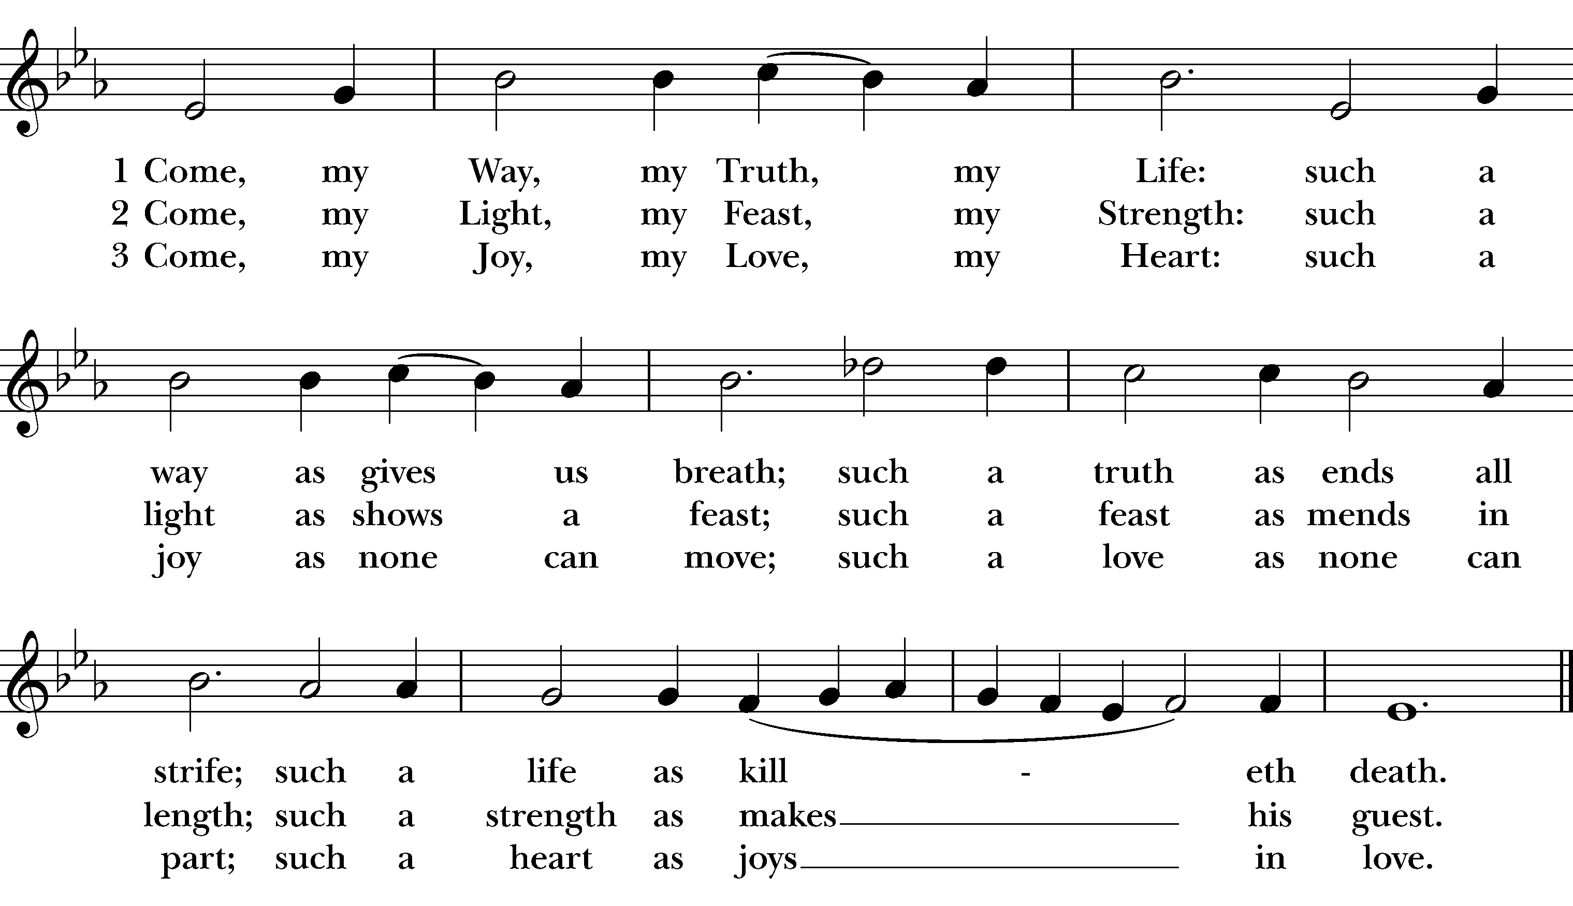

Post Communion Prayer
Presider: Let us pray
Please stand

People: Eternal God, heavenly Father, you have graciously accepted us as living members of your Son our Savior Jesus Christ, and you have fed us with spiritual food in the Sacrament of his Body and Blood. Send us now into the world in peace, and grant us strength and courage to love and serve you with gladness and singleness of heart; through Christ our Lord. Amen.

The Easter Blessing

May Almighty God, who has redeemed us and made us his children through the resurrection of his Son our Lord, bestow upon you the riches of his blessing. Amen.

May God, who through the water of baptism has raised us from sin into newness of life, make you holy and worthy to be united with Christ for ever. Amen.

May God, who has brought us out of bondage to sin into true and lasting freedom in the Redeemer, bring you to your eternal inheritance. Amen.

And the blessing of God Almighty, Creator, Christ, and Holy Spirit, be upon you and remain with you for ever. Amen.

Recessional When Christ Was Lifted from the Earth Hymnal #603

Dismissal
Deacon: Go in the Peace of Christ. Alleluia! Alleluia!
People: Thanks be to God. Alleluia! Alleluia!

Postlude Marche Royale Jean-Baptist Lully

Announcements
Thank you to the Bargain Box. The Bargain Box has generously donated $3,500 to Good Shepherd to help complete our patio project. We will be installing a retractable awning to allow for shade when outdoors thus summer for Coffee Hour. THANK YOU!
Spring Auction: Spring Auction is just a two weeks away. See today’s flyer for details. If you plan to attend, you can sign up on line or there is a sign up sheet on the bulletin board. Don’t miss this fabulous evening of fun and fellowship! Sign up today!
Reading Food Bank: Drop off on Sunday or during office hours. There is a box in front of the side altar. Needs List: Cookies, Hot chocolate, Snack crackers, Paper Towels, Toilet paper, Laundry detergent.
Bread of Life: Save the Date! Saturday, May 21st, from 10am-2pm. Please join us as we celebrate Bread of Life’s wonderful volunteers. Meet Bread of Life’s new volunteer coordinator, Eileen, and tour our food pantry warehouse. Refreshments will be served.
The Bargain Box: The Bargain Box is open on Fridays from 10:00 AM – 3 PM and on Saturdays from 10:00 AM- 1:00 PM. For more information contact Martha at jacksnana1@verizon.net or 781-944-6964. We are especially in need of clothing donations. Donations for the Bargain Box can be dropped off Wednesday, 8:00a.m.-12:00p.m. and during the hours that the shop is open on Friday and Saturday.
Coffee Hour: Coffee hour is back. Jan Kelly will make coffee every Sunday, and set up the coffee buffet. We need volunteers to sign up to bring treats, beverages and to clean up. If you would like to help, there is a sign up sheet in the kitchen.
Birthdays This Week: Connor Edge, Rob Goodwin, Leslie McGovern, Kevin Delano, Katherine Luddy, and Alexander Witham.

Anniversaries this week: Jack and Karen Marlin, and Rob and Stephanie Klages.

For Your Prayers This Week: Rebecca Bellistri, Jennifer Chapman, Marge Clogston, Edith Cooper, Jacob Cote, Margaret Cowell, Keith Curtis, Kerry Dunnell, Margaret Enderle, Carlo Esidore, Jeffrey Gates, Gloria Graves, Amanda Hanson, Linda Johnnene, William Kirkby, Ann Marie Lannin, Rachel Manzelli, Linda McCarthy, Marcia Muir, Joan and Arthur Paradis, John Parsons, Sandy Rossini, Bill Webb, Kathy Platti, Lee Conley and The McInerney Family.

Book of Remembrance: Judi Kyle-Brenna, Jeannette Crouse, Margaret Wrigley, G. Virginia Bowen, Ida May Ives, Jean E. Serrentino, Edward Forrest, Juerge Staudte, Jackie Louzan, William Dresser, Henry Sletterink, Joseph McDonald, Edward Chandler.

Altar Flowers: In memory of Frank and Eleanor Dalrymple, by their Children, Joseph McDonald, by his family, and Philip Royce by Judith Royce.

Sanctuary Lamp: In Memory of our parents, Len and Eileen Brescia and Edwin and Marion Kelly, by Neil and Jan Kelly.

Bread of Life Sponsors for May: Erica and Randy Palm, Carla Lynch.

Diocesan Cycle of Prayer:
Parishes of the Merrimack Valley Deanery
St. James Church, Amesbury, Christ Church, Andover, All Saints’ Church, Chelmsford, St. James’ Church, Groveland, Trinity Church, Haverhill.

Today’s Lay Ministers in Liturgy: Lector: Neil Kelly, Ushers: Dave and Edna McDonald.

Parish Leadership and Contact Information

The Rev. Brian Raiche, Rector
The Rev. Pete Jeffrey, Deacon in Residence
Alice Johnson Hannon, Music Director
Jane Farrar, Pastoral Associate
Jan Kelly, Administrator

Joyce Witham, Senior Warden;
Robert Newton, Junior Warden;
Barbara Luddy, Treasurer
Jan Kelly, Clerk
Vestry Members: Petra Conboy, Shaun Neville, Maria Nicholson, Erica Palm,
Bob Sorrentino, Bob Stasonis,
Jill Silva, Robert Webber, Brenda Woodbury

Office Hours:
Monday, Wednesday, Thursday
9:00 AM- 1:00 PM
Bargain Box
Friday, 10:00 AM-3:00 PM
Saturday, 10:00 AM-1:00 PM

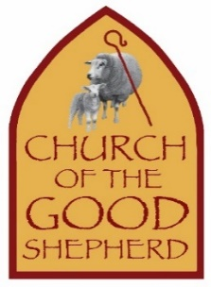
95 Woburn St., Reading, MA 01867
781-944-1572
office@goodshepherdreading.org
RevBrian@goodshepherdreading.org
www.goodshepherdreading.org

Music reprinted with permission. OneLicense #A-726512.
Permission to podcast/stream the music in this service obtained from One License with license #A-726512.

